**DAILY ONLINE ACTIVITIES SUMMARY**

|  |  |  |  |  |  |  |  |
| --- | --- | --- | --- | --- | --- | --- | --- |
| **Date:** | **20-05-2020** | | | | **Name:** | **Laxminarayan Miskin** | |
| **Sem & Sec** | **4TH SEM A** | | | | **USN:** | **4AL18CS044** | |
| **Online Test Summary** | | | | | | | |
| **Subject** | | **OBJECT ORIENTED CONCEPT** | | | | | |
| **Max. Marks** | | **30** | | **Score** | | **12** | |
| **Certification Course Summary** | | | | | | | |
| **Course** | **GOOGLE ANALYTICS** | | | | | | |
| **Certificate Provider** | | | **GOOGLE** | **Duration** | | | **4 HOURS** |
| **Coding Challenges** | | | | | | | |
| **Program 1:Write a c program to Reverse a Linked List(SLL) in groups of given size.**  **Program 2: Given an array a[] of size n which contains elements from 0 to n-1, write a program print Duplicates which prints the duplicate elements of the given array. If no duplicate element is found print -1.** | | | | | | | |
| **Status:Executed** | | | | | | | |
| **Uploaded the report in Github** | | | | **YES** | | | |
| **If yes Repository name** | | | | **https://github.com/lax04/LockdownCoding**  **https://github.com/lax04/LockdownCodinginJava** | | | |
| **Uploaded the report in slack** | | | | **YES** | | | |

**Online Test Details:**

18CS43 The online test was from module 1 which was about Introduction to C++.There were 30 questions and the duration was 45 minutes.The score of this online test was 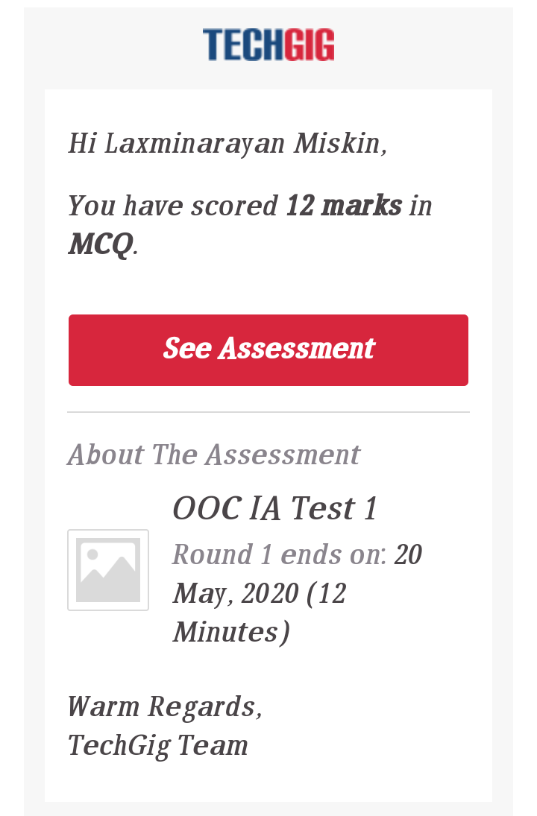12/30.

**Certification Course Details:**

Course Name:GOOGLE ANALYTICS FOR BEGINNERS

Today learnt about:

1.Audience Reports, Acquisition reports,Behavior reports and overview.

2.How to measure customs campaigns and how to track marketing campaign.

3.Tracking campaigns with the URL builder.

4.Use goals to measure business objectives.

5.How to measure Google Ads campaigns.

Finished with the Assessment 3 and 4 .

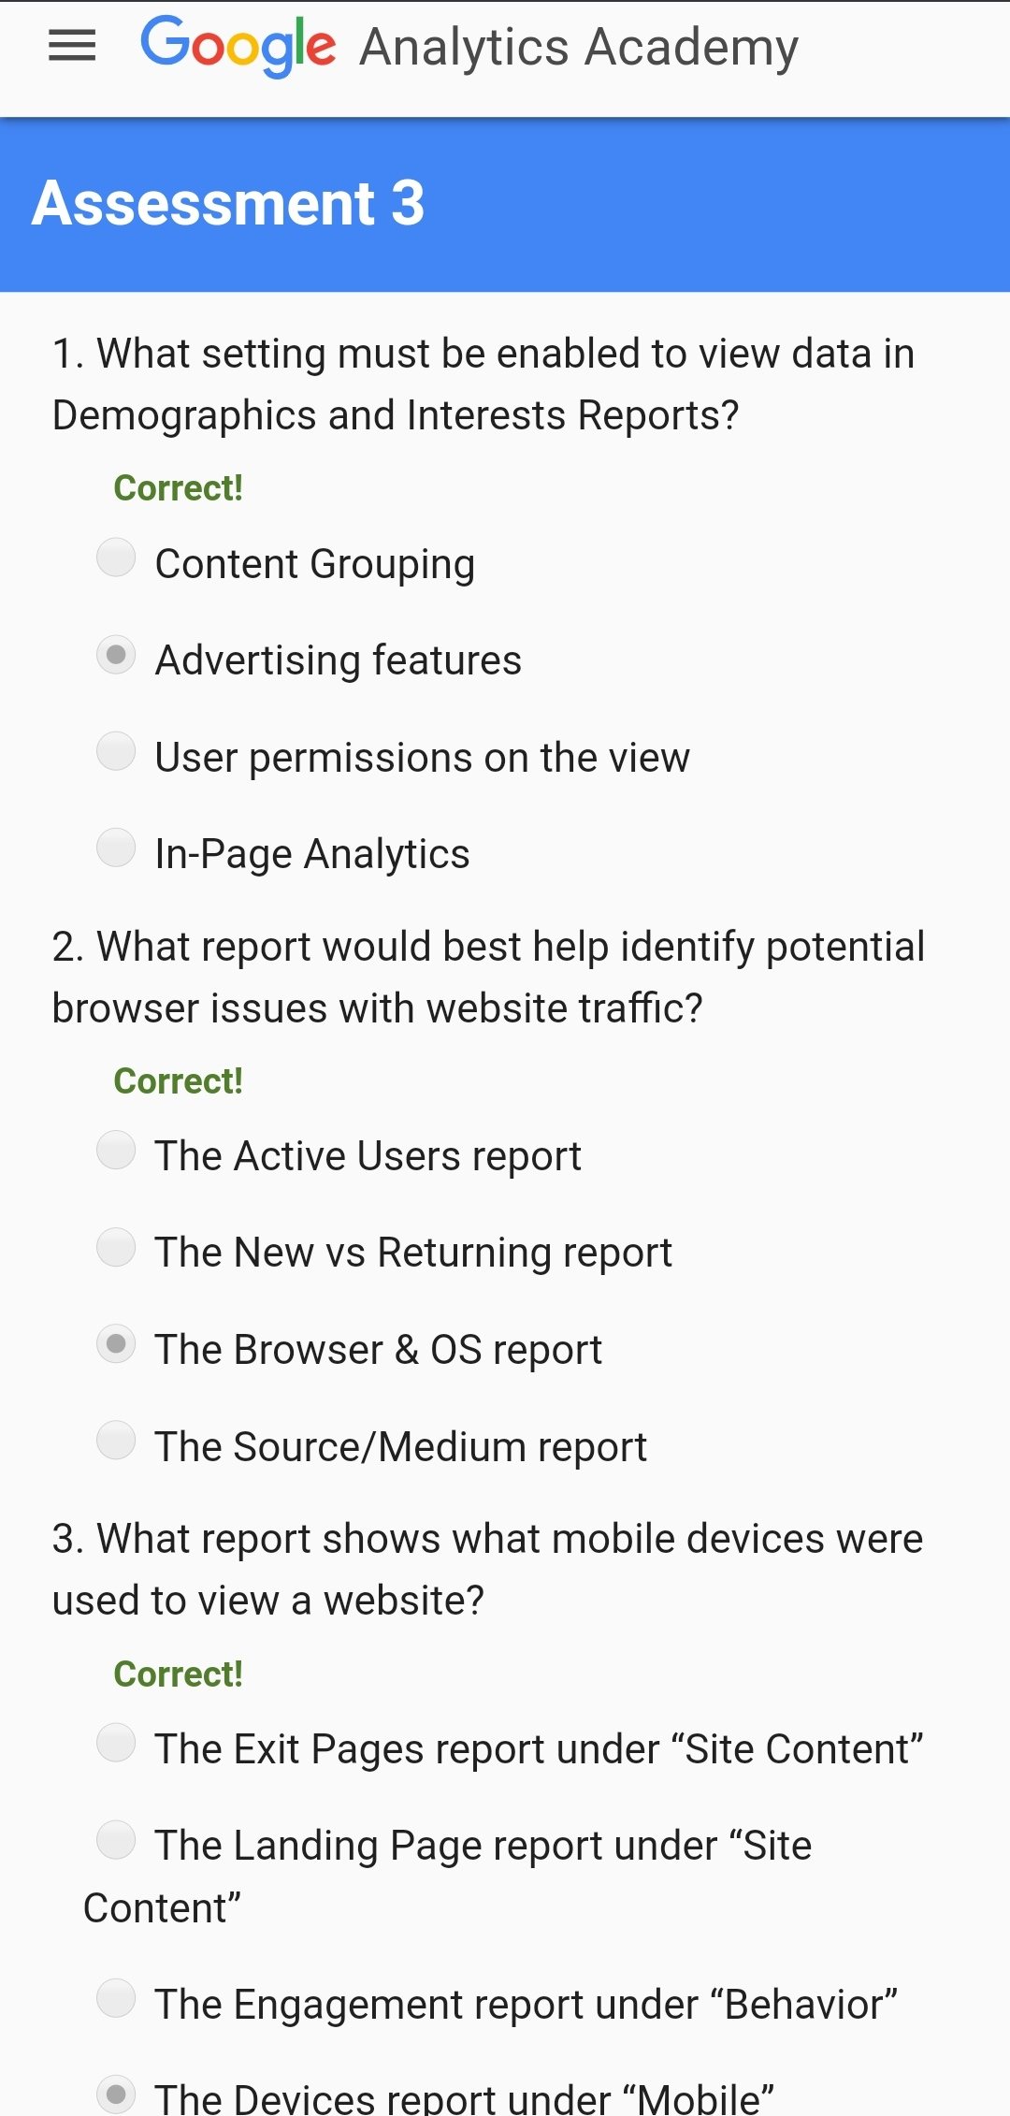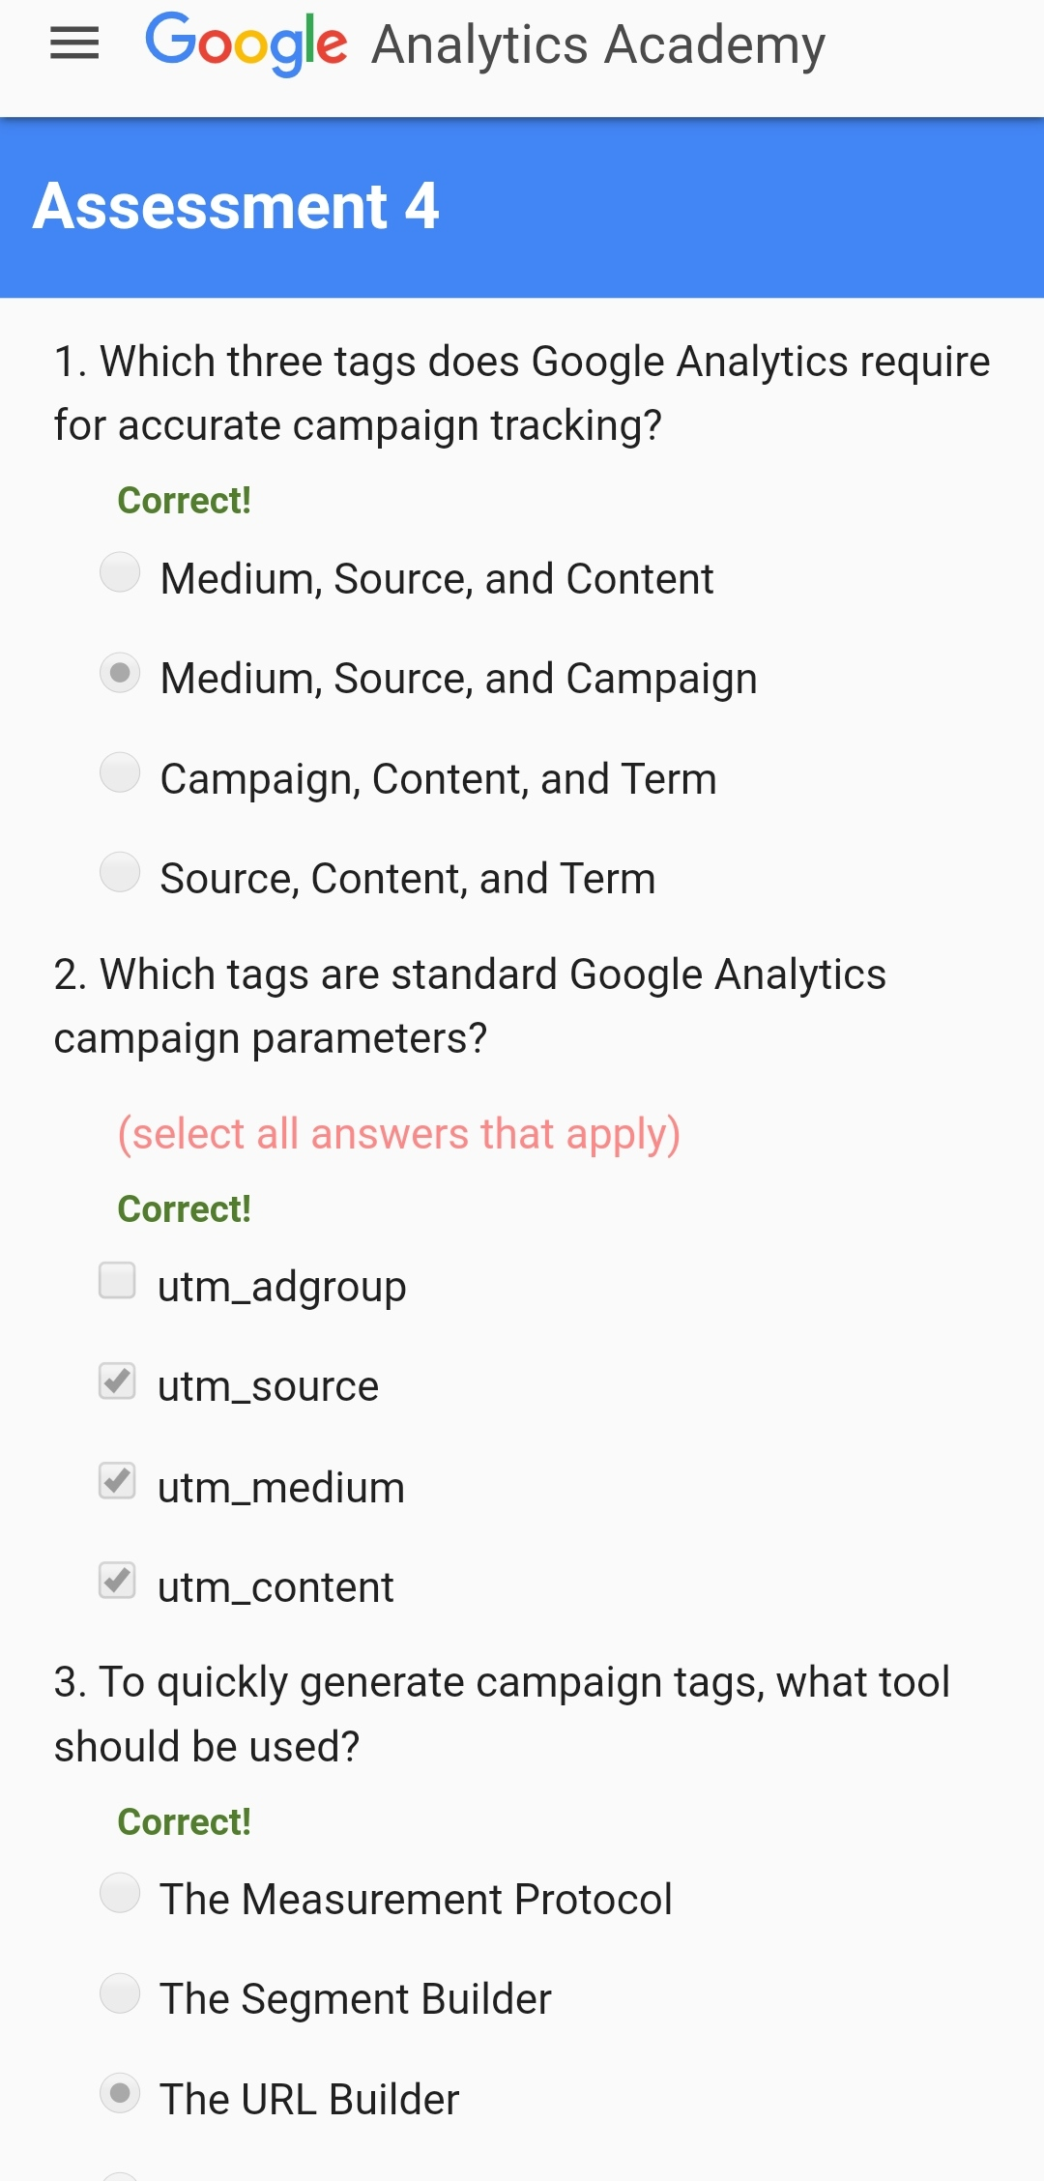

Completed with the" GOOGLE ANALYTICS FOR BEGINNERS" certification course and the above certificate was issued from GOOGLE ANALYTICS ACADEMY.

**Coding Challenges Details:**

1.Write C Program to Reverse a Linked List(SLL) in groups of given size.

Test Case 1:  
If a linked list is: 1 → 2 → 3 → 4 → 5 → 6 → 7 → 8  
The value of size k is 2  
Then the linked list looks like: 2 → 1 → 4 → 3 → 6 → 5 → 8 → 7

Test Case 2:  
If a linked list is: 1 → 2 → 3 → 4 → 5 → 6 → 7 → 8  
The value of size k is 3  
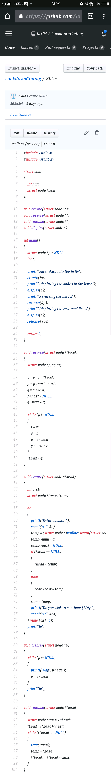Then the linked list looks like: 3 → 2 → 1 → 6 → 5 → 4 → 8 → 7

2.Given an array a[] of size n which contains elements from 0 to n-1, write a program print Duplicates which prints the duplicate elements of the given array. If no duplicate element is found print -1.  
Input:  
The first line of input must contains an integer n which denotes number of elements of Array. Second line contains n space separated integers denoting elements of array a[].

Output:  
Print the duplicate elements from the given array

